Minimum System Requirement for SWIM Portal

Contents
Internet Explorer Version 2
Internet Explorer Advanced Settings 3
Certificate Setting 12
Firefox Version supported (planned for Mac Users or non Windows users) 14
Java Settings (necessary for UWL functionality and other Transaction iViews like Invoicing) 15

This document covers the minimum settings that should be present in the users PCs (Windows or Mac) to work on the SWIM Portal

Internet Explorer Version
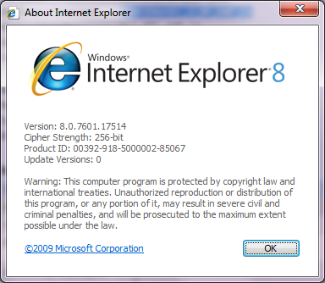

Internet Explorer Advanced Settings
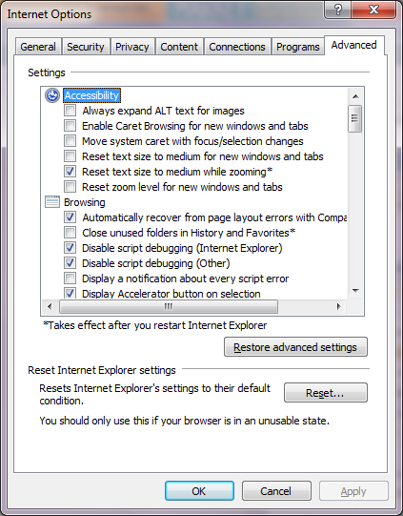
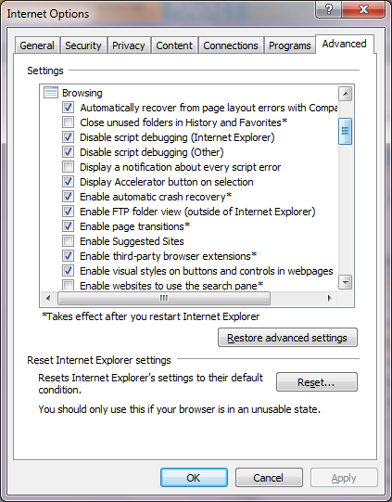
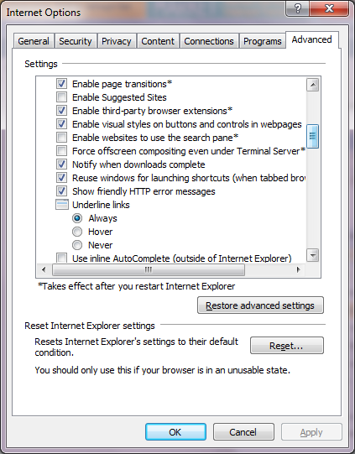
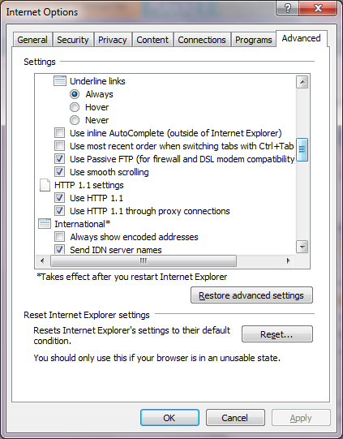
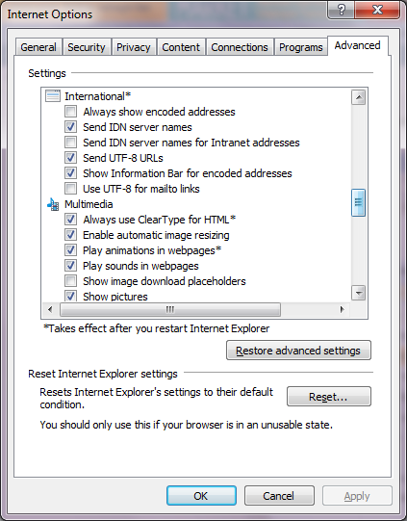
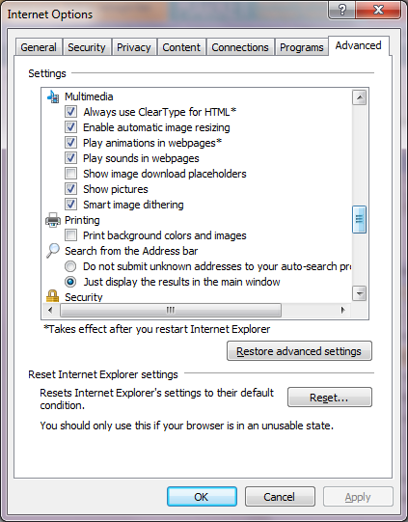
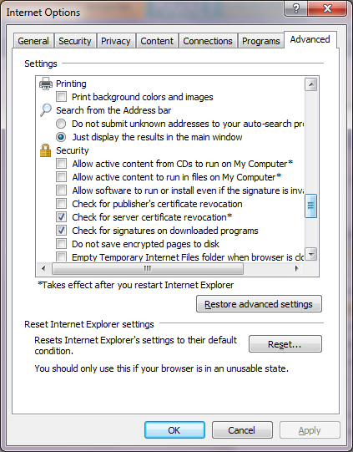
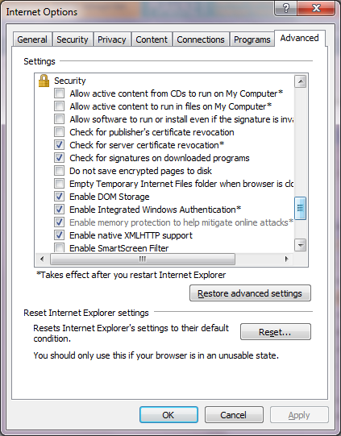
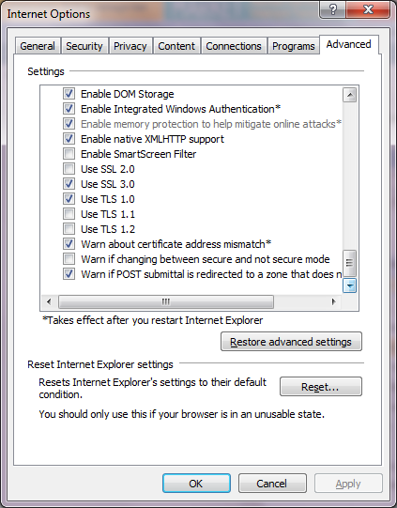

Certificate Setting
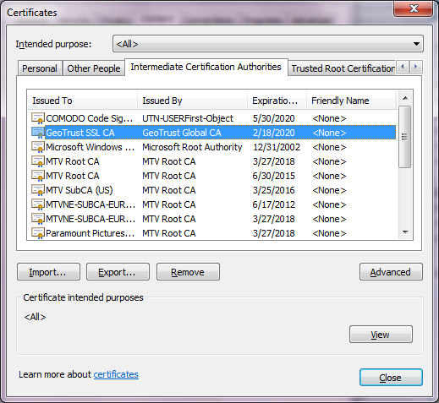
The certificate (signed) must be installed in the Intermediate Certification Authorities and Trusted Root Certification authorities
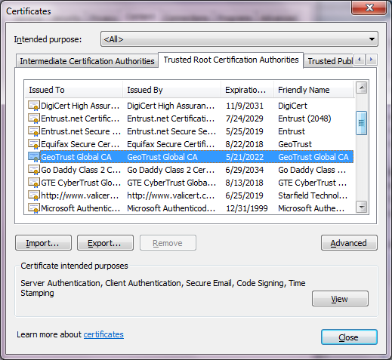

Firefox Version supported (planned for Mac Users or non Windows users)
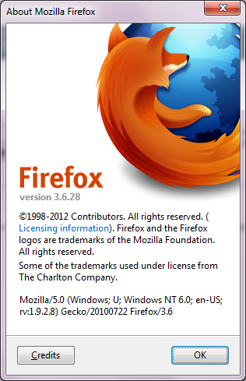

Java Settings (necessary for UWL functionality and other Transaction iViews like Invoicing)

